

**Western Governor’s University**

Digital Forensics in Cybersecurity

C431

Joshua Lee

BFN2 Task 2: Forensic Investigation

**A1. STEPS USED TO CREATE FORENSICS CASE FILE**

1. First step is that I started up the Autopsy program to create a New Case.

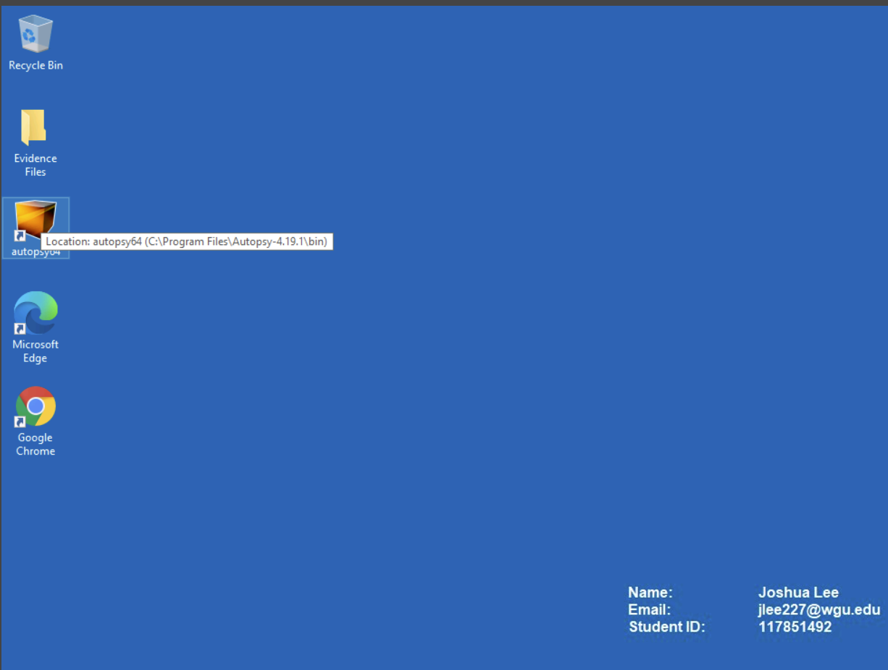

1. Then I added the Case Information, along with the Base Directory of C:\Users\LabUser\Desktop\Evidence Files to store case data.

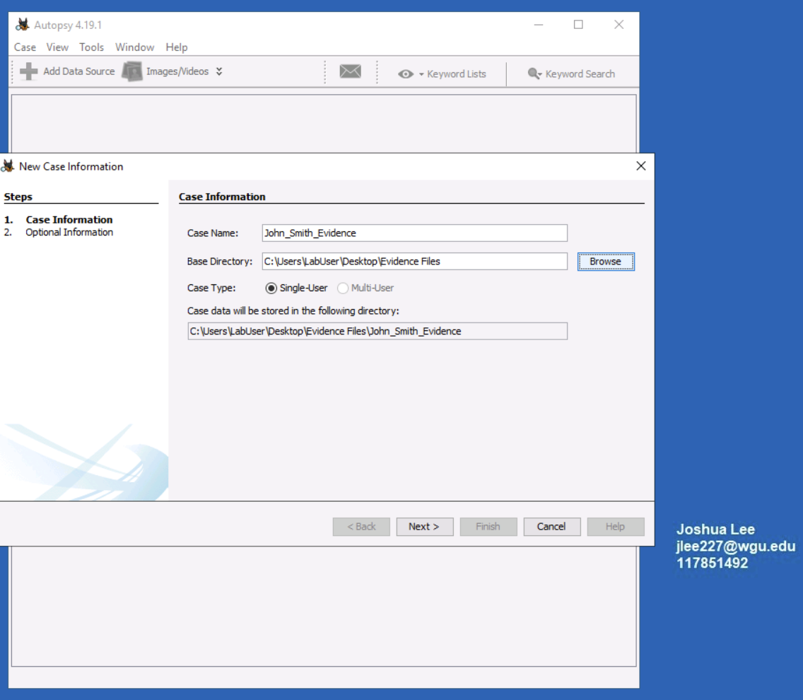

1. I added the case number 117851492 and my examiner number to complete the New Case information submission.

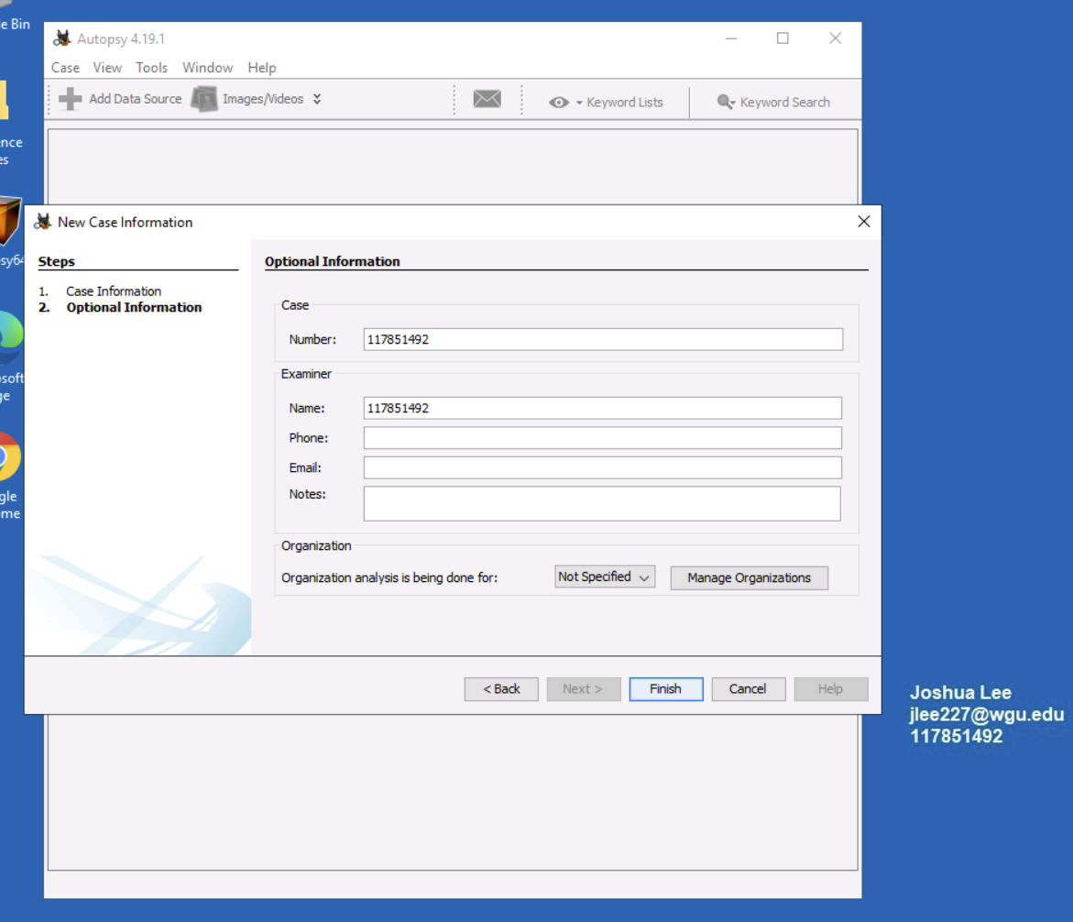

1. In the Select Host portion, I kept the default settings and continued to the next step.

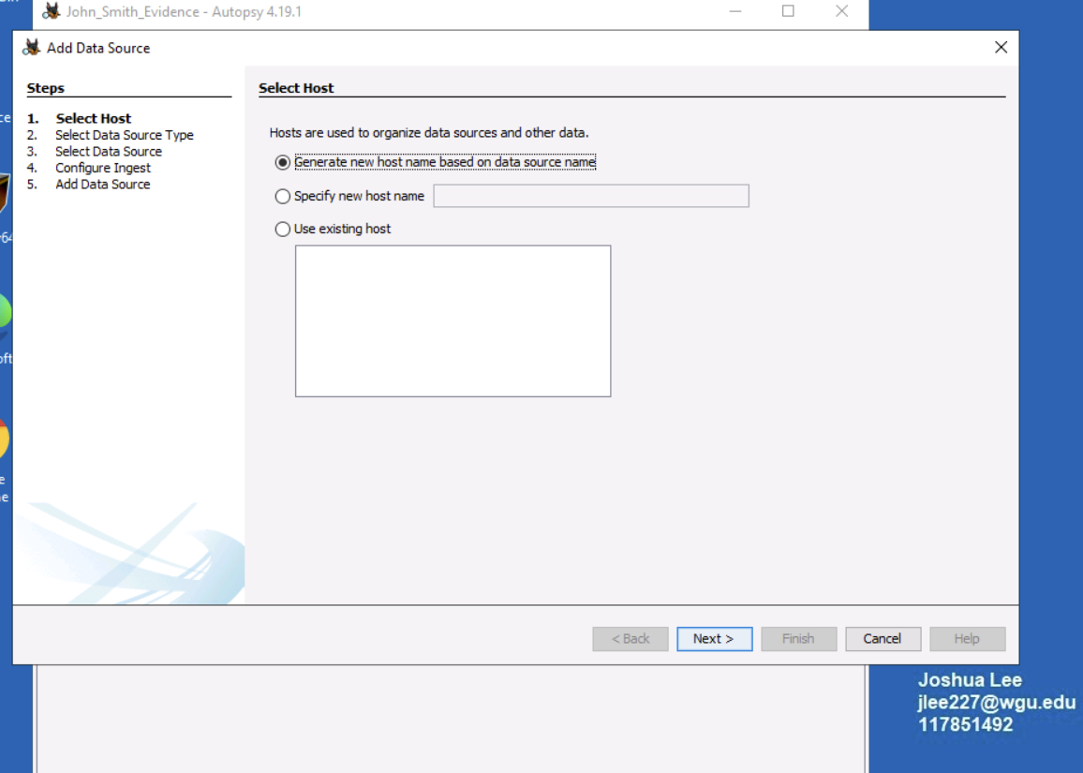

1. Selected Disk Image or VM file for the Data Source Type and continued to the next step.

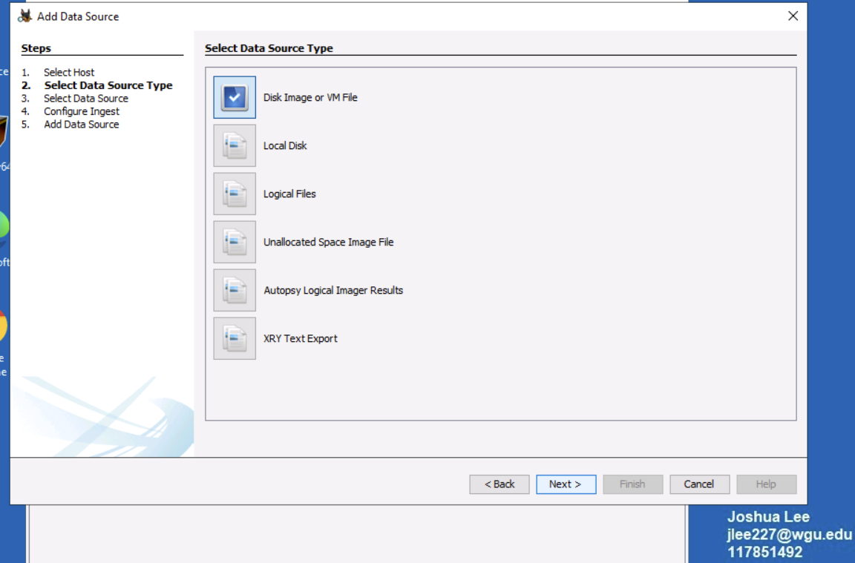

1. Selected the Data Source path as C:\Users\LabUser\Desktop\Evidence Files\JSmith_Q1.001 and kept the rest of the settings as default in the Select Data Source step.

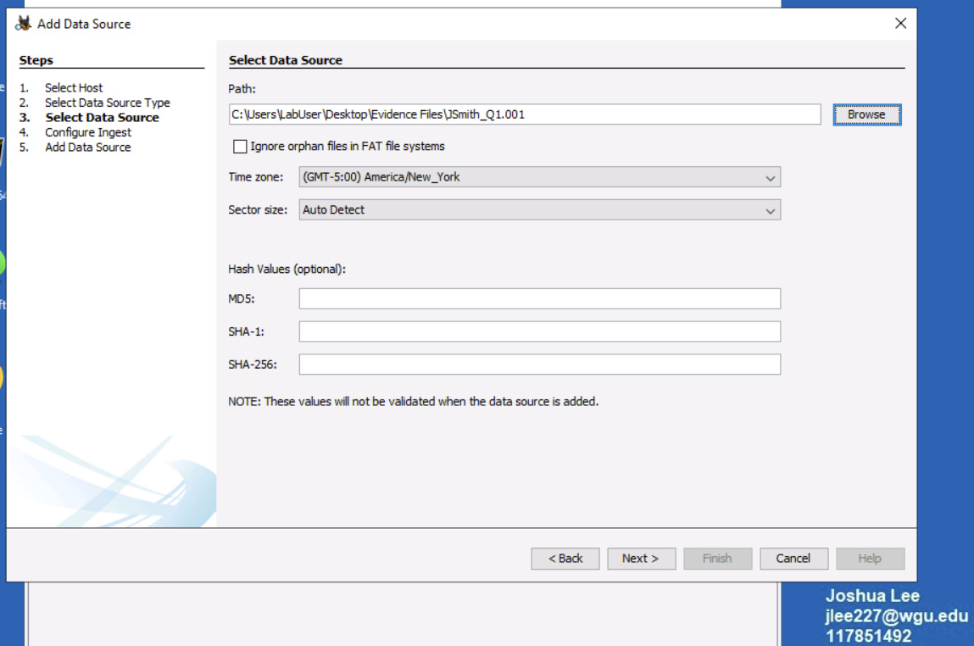

1. Kept the default settings in the Configure Ingest step and continued to the next step.

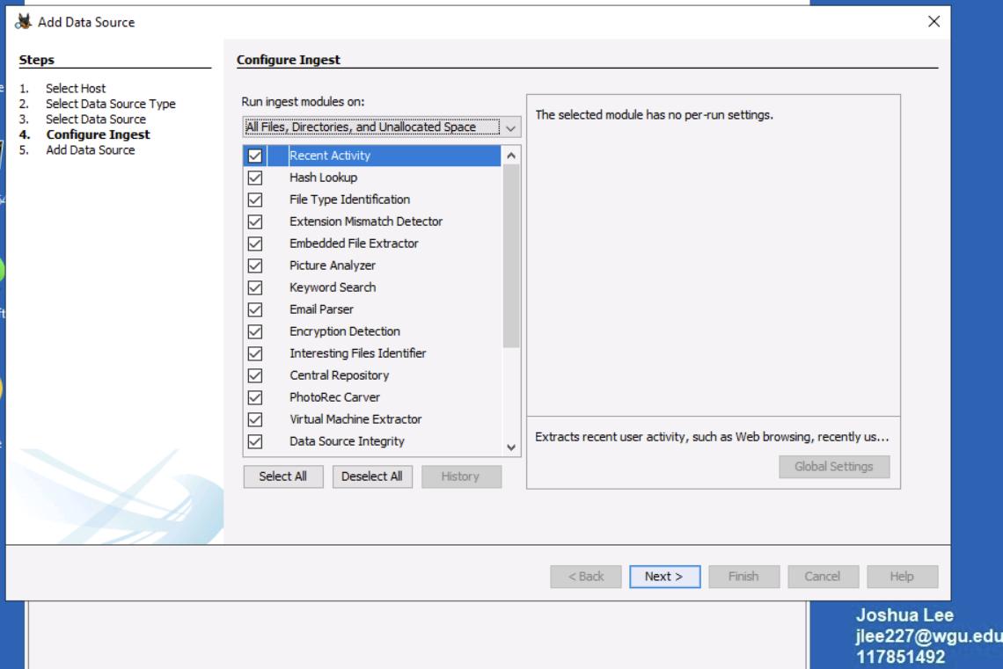

1. The process ran in the Add Data Source step, and it let us know that the Data Source was added to the local database and files are being analyzed.

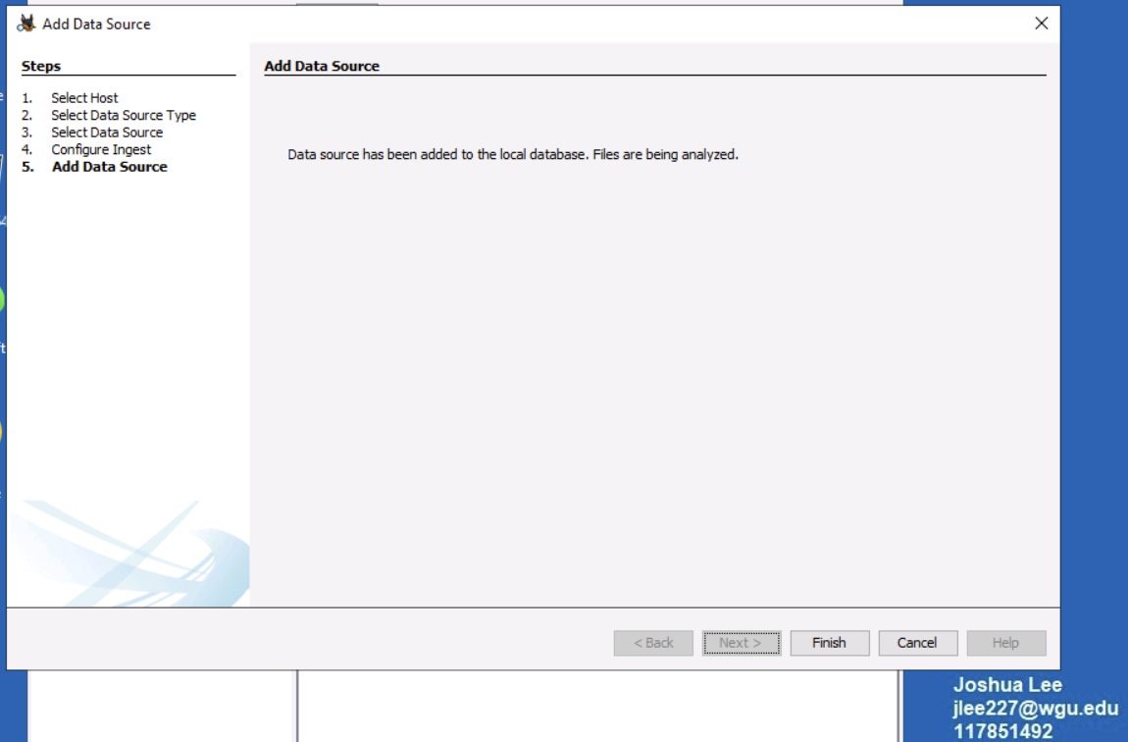

**A2. STEPS USED TO IDENTIFY POTENTIAL EVIDENCE**

1. First in the actual drive, I looked in Data Sources\JSmithQ1.001_1 Host\ JSmithQ1.001\$Carved Files. File carving is a process used to recover files from unallocated space without any file information and used to recover data for a digital forensic investigation (*File Carving | Infosec*, n.d.). According to Senior Management, John is not supposed to have access to proprietary information. In the Carved Files folder, there were two delted pdfs were reconstructed that were showing as Confidential (Business Strategy PDF and Drilling Methodology PDF)

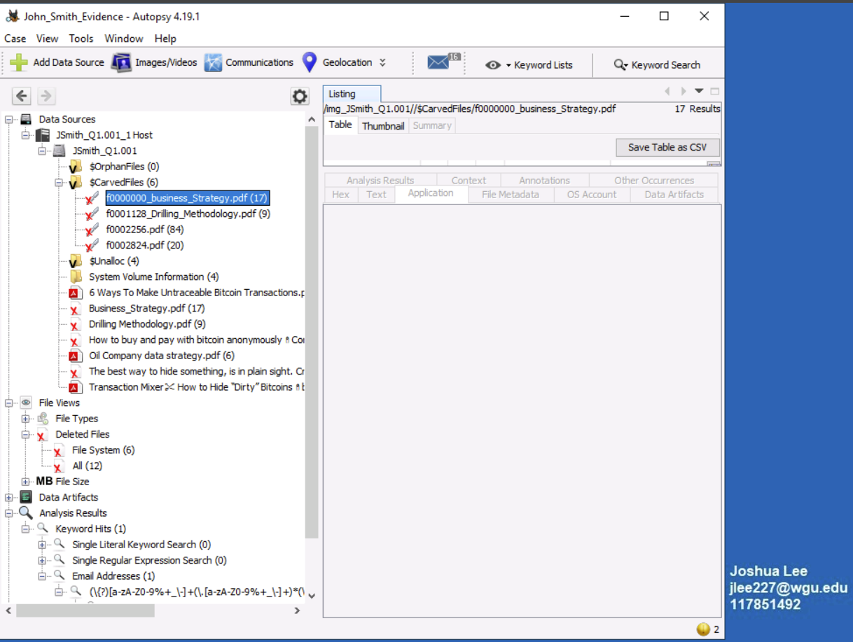

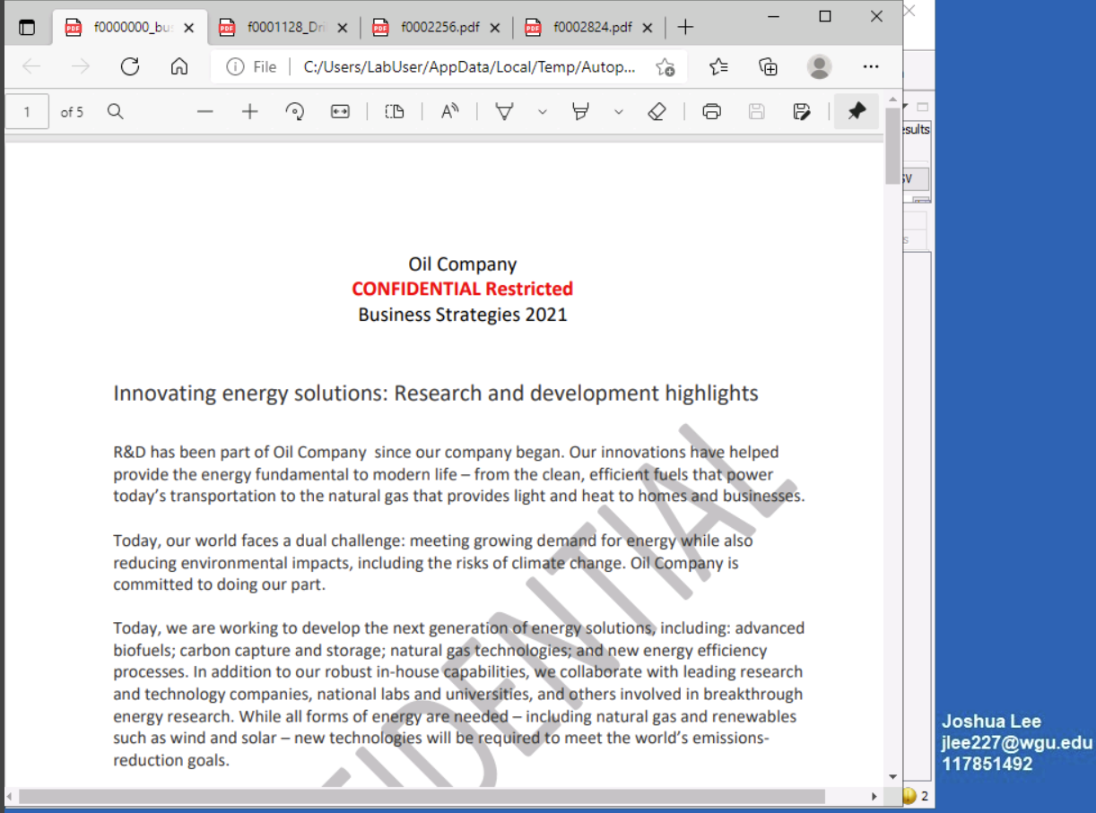

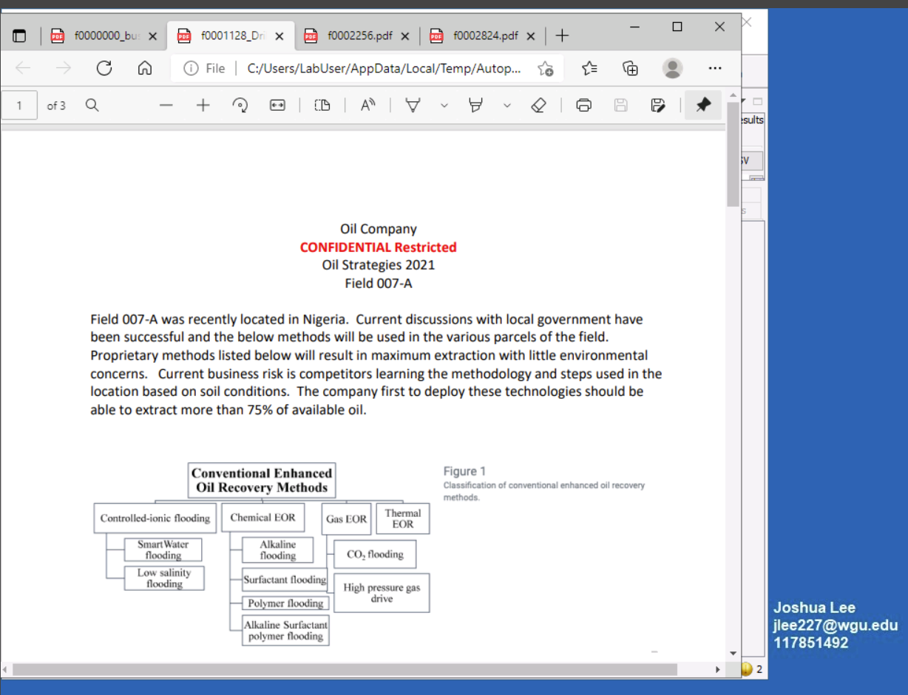

In addition, the other two PDFs in there gave suspicion to possible selling of the data as it referenced how to buy and pay with bitcoin anonymously and Crypto Laundering articles. 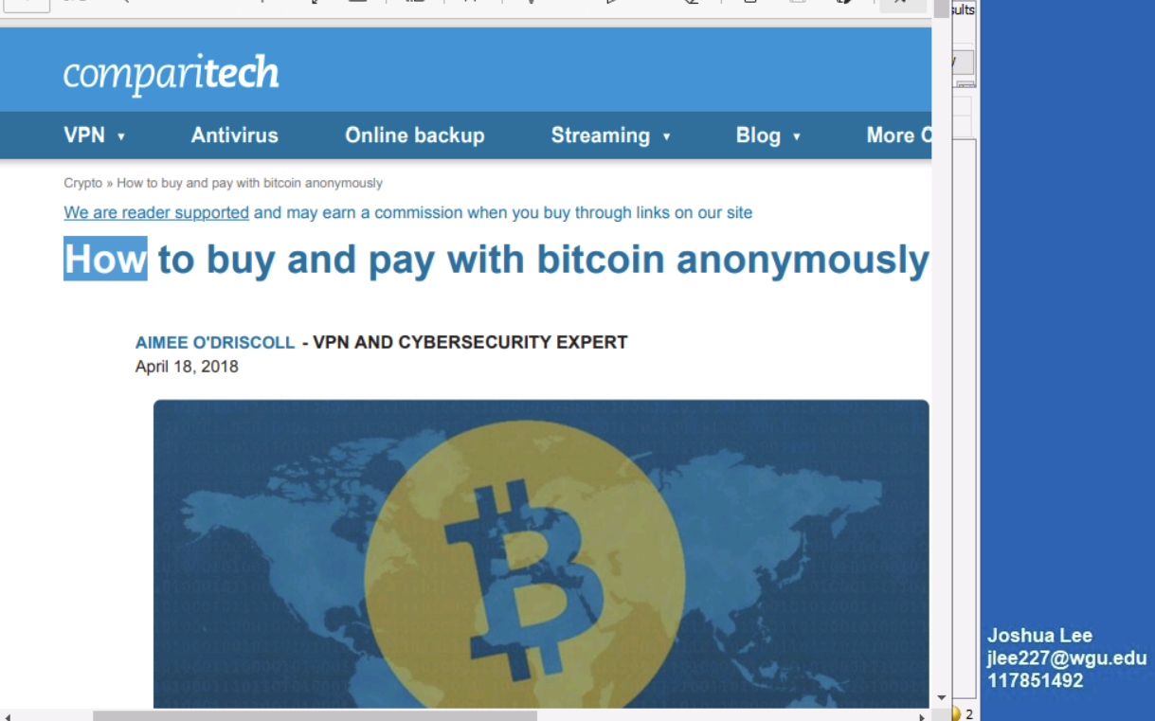

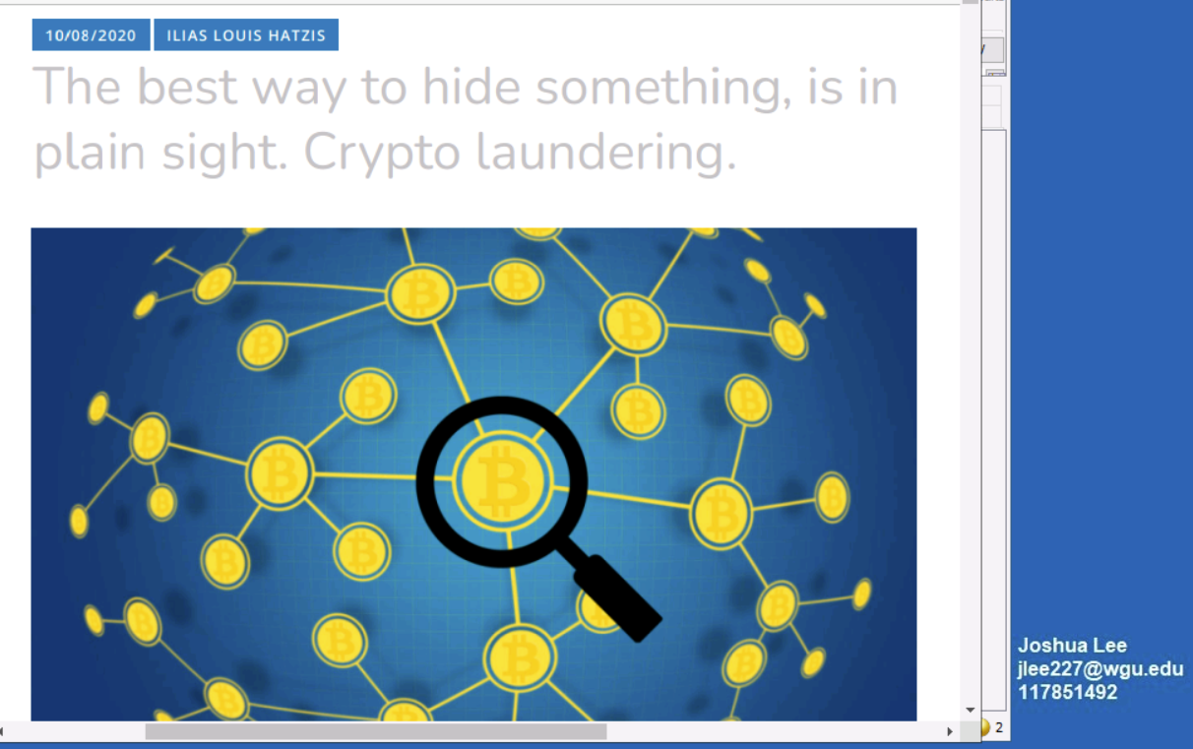

A deleted file was also found while searching the drive itself along with another No Release – Confidential document which contained strategic data management and analytic tactics, as well as a couple more documents related to How to Make Untraceable Bitcoin Transactions and How to Hide Dirty Bitcoins

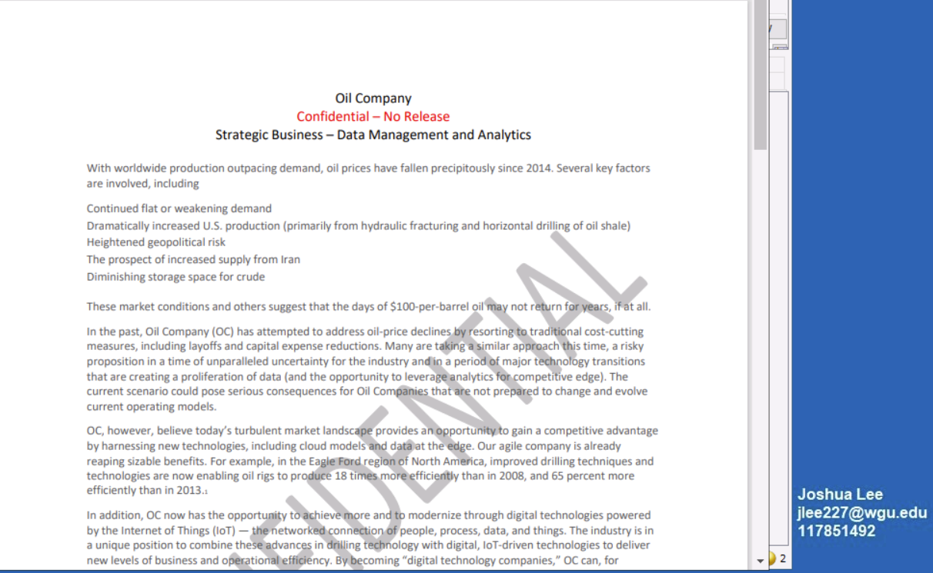

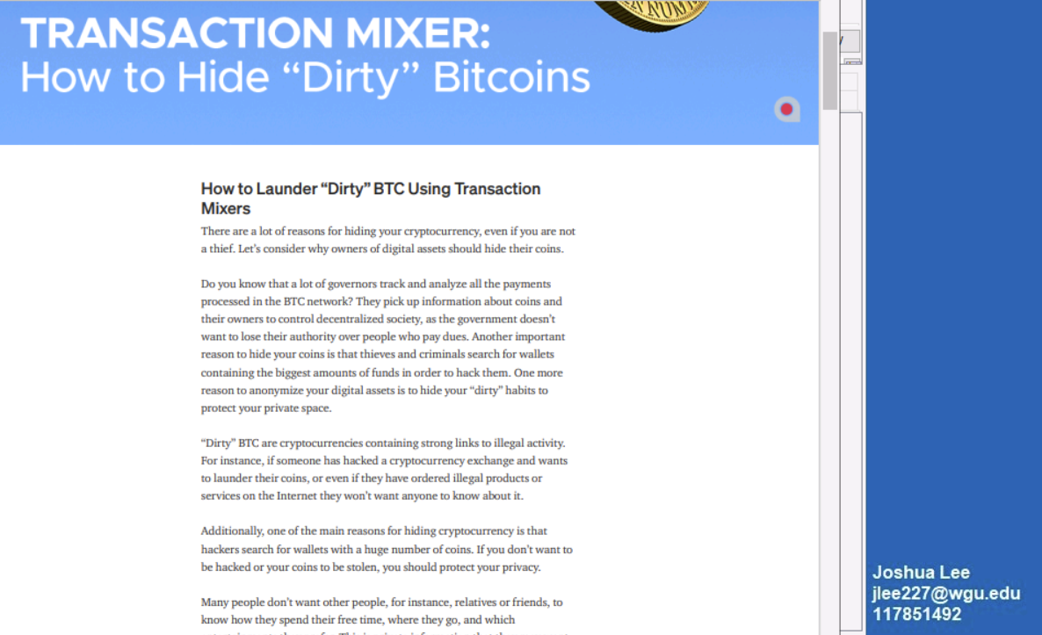

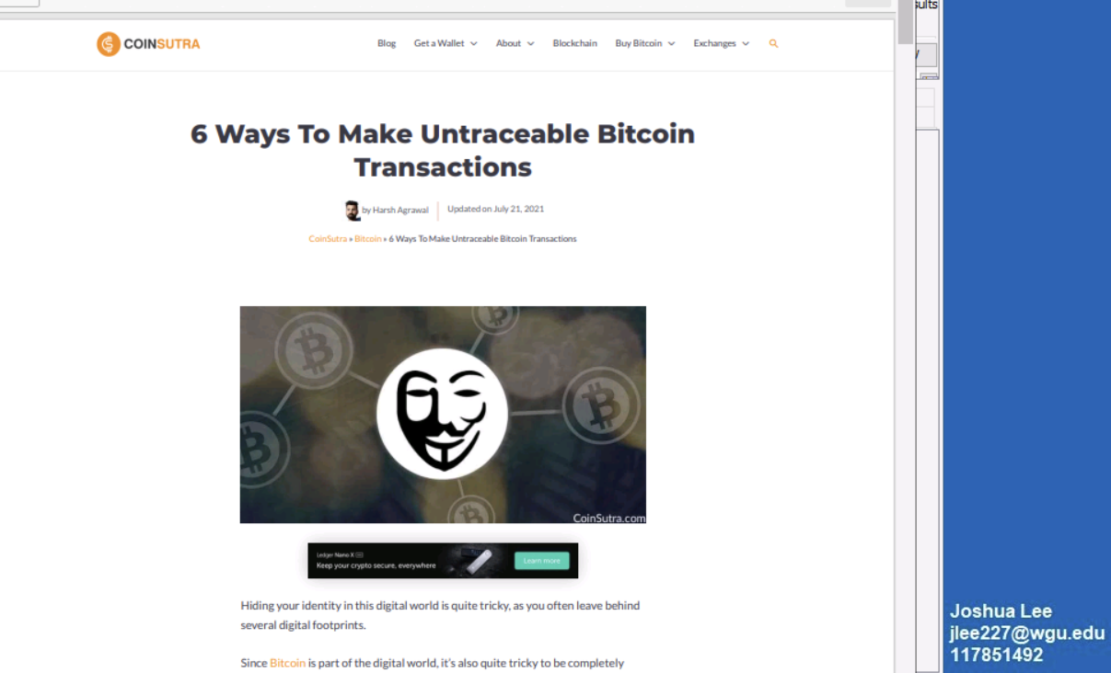

1. These files along with a couple more diagram JPG files named Oil_co_conf and oilco_conf2 related to the oil drills and processes showed up in File Views\Deleted Files. They were not marked confidential on the images like the other documents, but Senior Management would be able to determine if they were.

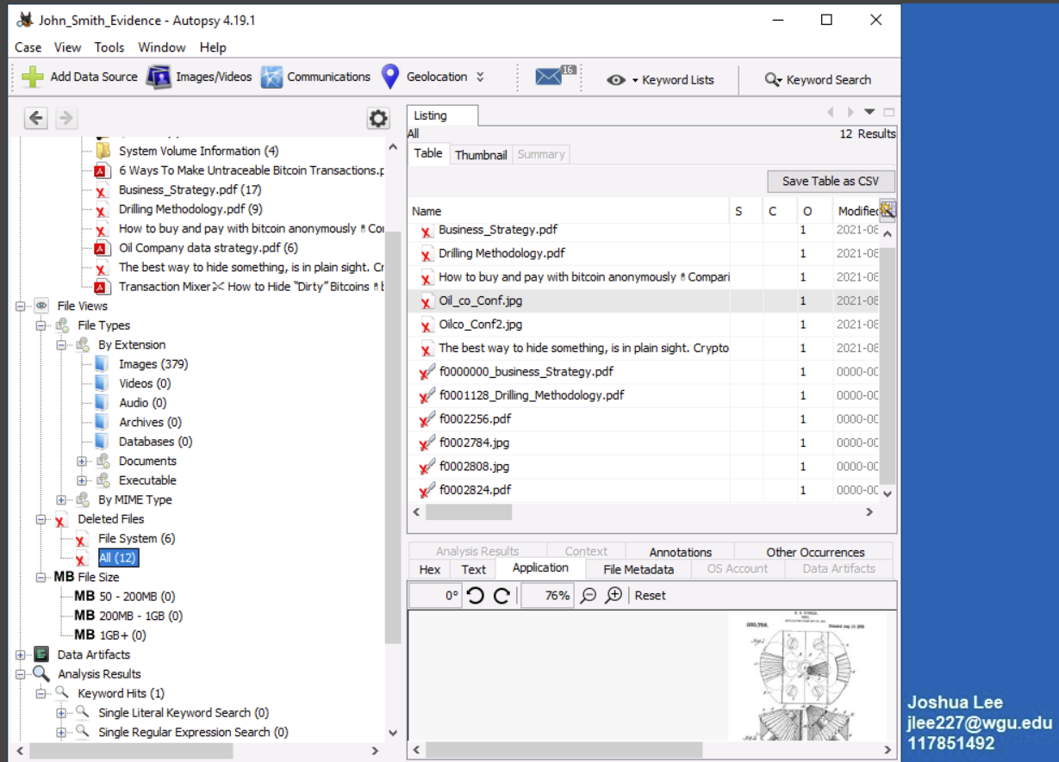

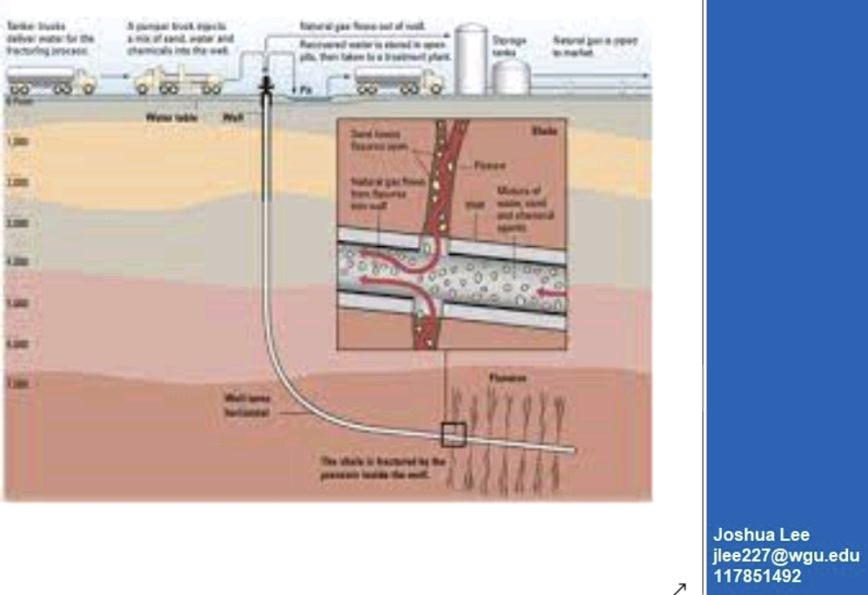

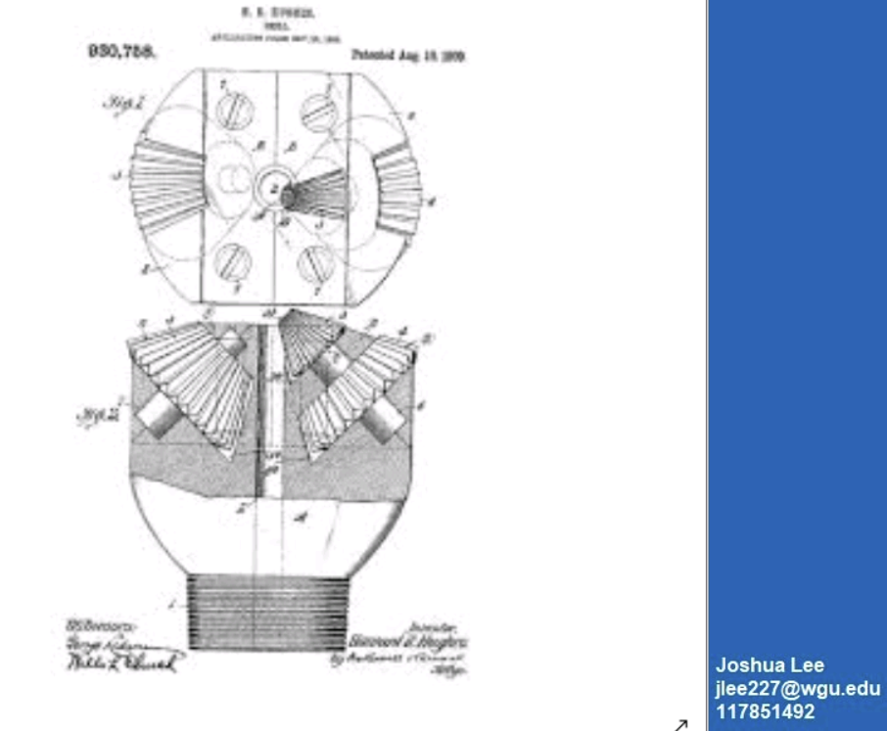

1. Doing a keyword search by creating a list that had the words confidential, proprietary, and restricted, these same documents came up in the list. When searching for only proprietary, Drilling Methodology is the only one that came up with that search term.

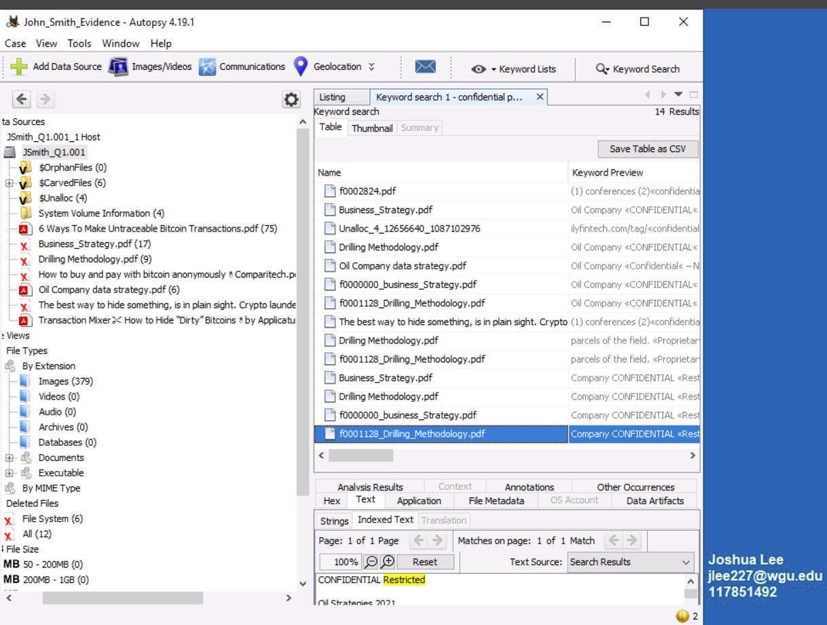

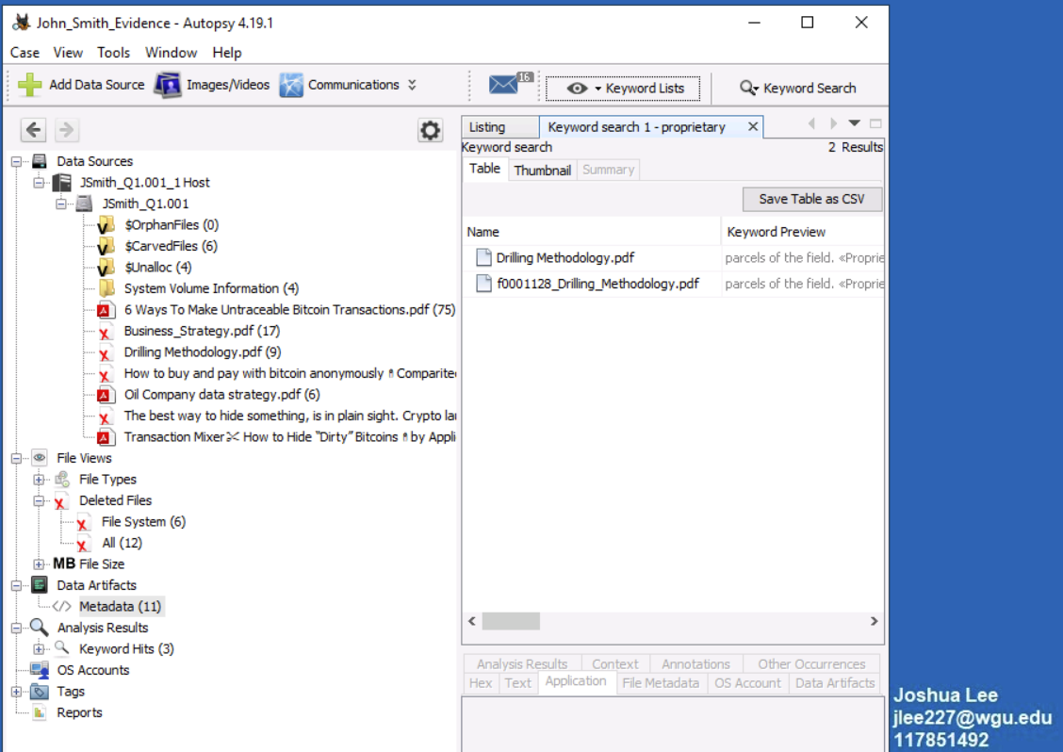

Also when doing a search for the keyword ‘illegal’ couple of the Bitcoin sites came up as hits  
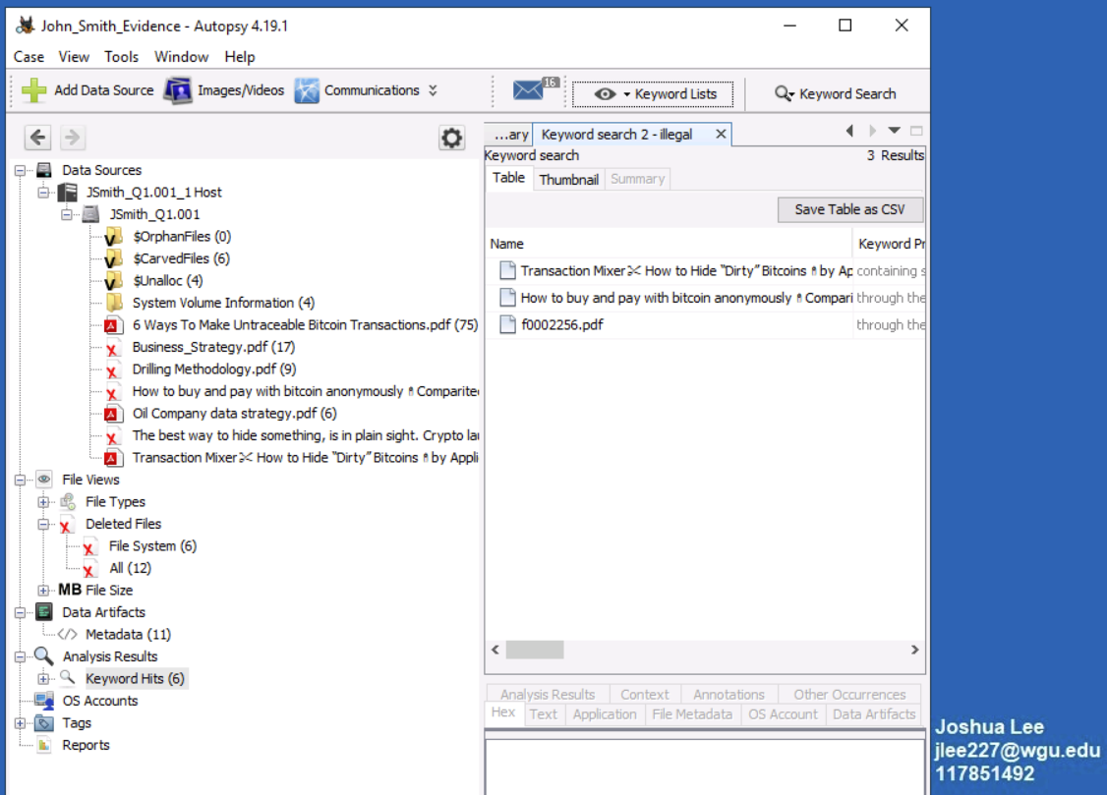

1. In the Timeline, the files for Drilling Methodology and Business Strategy were accessed on August 11th and saved. August 12th Oil Company data strategy.pdf, as well as a bunch of the Bitcoin articles referenced above were accessed and saved.

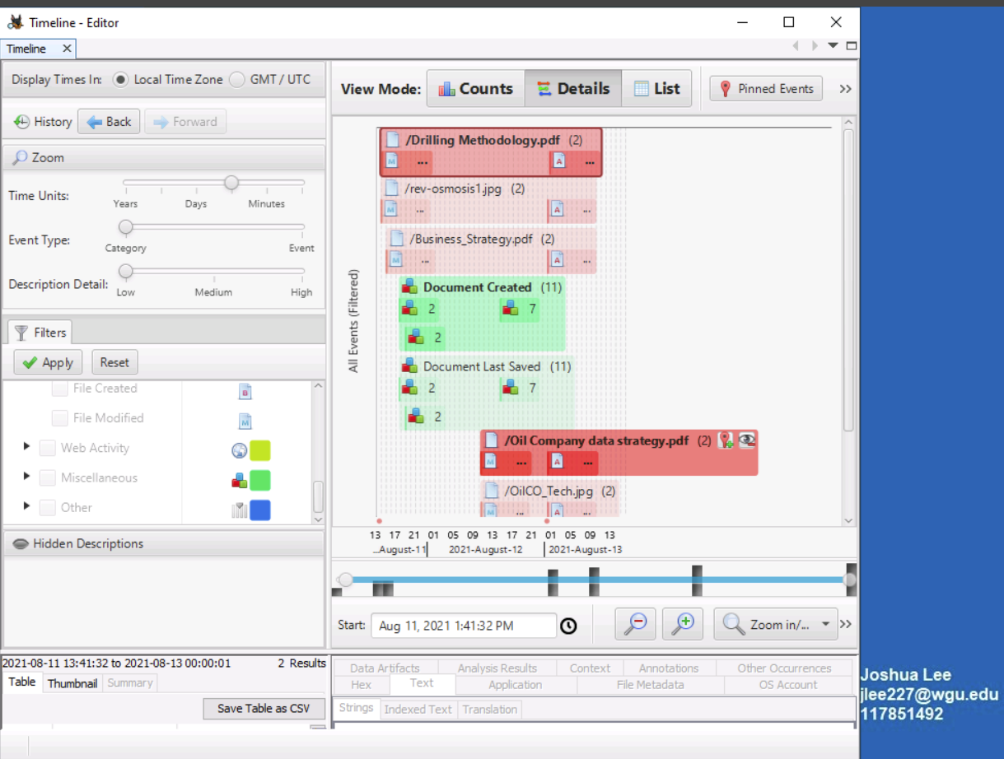

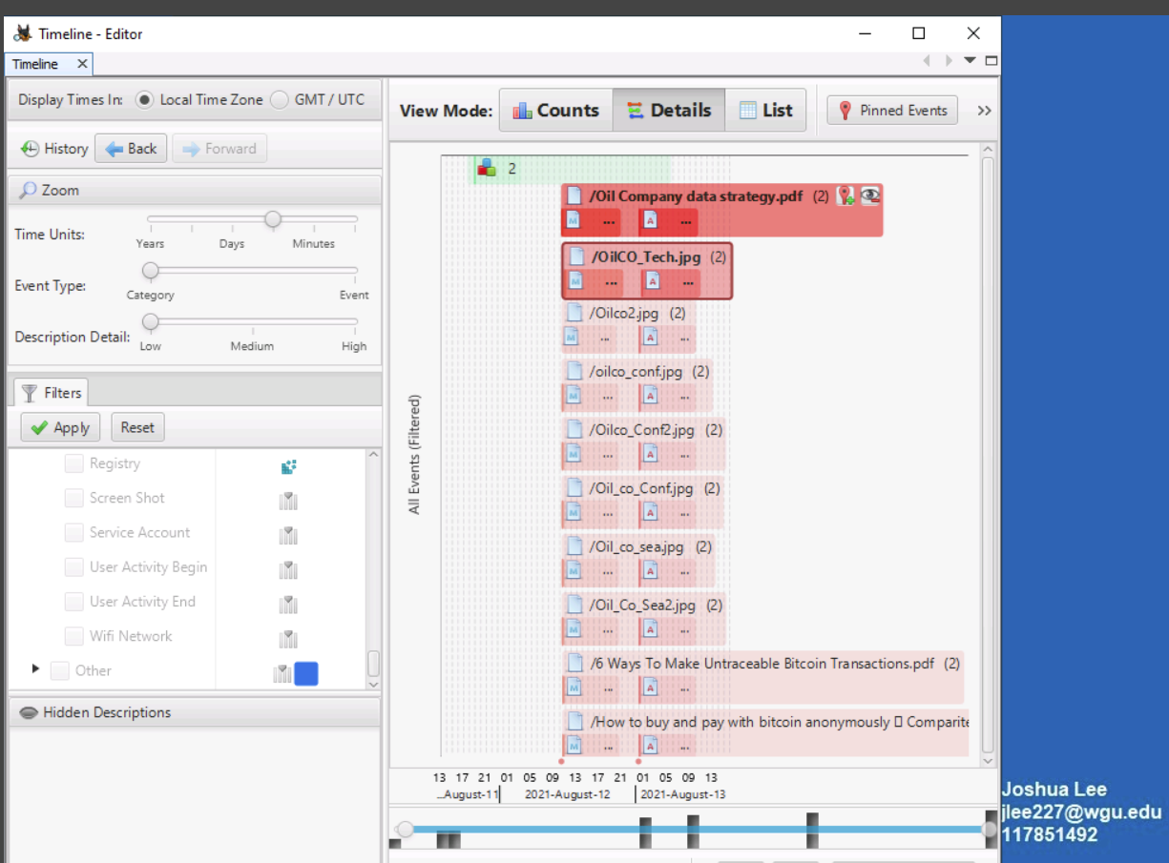

**A3. SUMMARY OF FINDINGS AND CONCLUSIONS**

While analyzing the drive image of John Smith’s workstation, we found many pieces of evidence that show he was accessing proprietary and confidential information. The files were Drilling Methodology, Business_Strategy, Oil Company data strategy PDFs, along with multiple jpgs related to drilling processes on land and sea. Drilling Methodology was the only one that came up with proprietary from a keyword search, but the others can be verified by Senior Management if Mr. Smith was supposed to have access to the others. There was also evidence of Mr. Smith researching how to make transactions with Bitcoin anonymously, as well as how to make these transactions untraceable and hidden. This leads to show Mr. Smith was either possibly looking to sell the data he acquired or was already in process of doing so. This violates the Non-Disclosure Agreement that all employees sign. The Acceptable Use Policy was also violated by researching the type of content relating to Bitcoin on the Oil Company’s equipment.

**References**

*File carving | Infosec*. (n.d.). Retrieved April 11, 2024, from <https://www.infosecinstitute.com/resources/digital-forensics/file-carving/>